BSCS FINAL PROJECT

Stock Market Forecasting



Project Advisor

Syed Atif Mehdi

Presented by:
Group ID: S21BS007

Student Reg# Student Name

L1S18BSCS0083 M. NAUMAN
L1F16BSCS0034 M. WALEED

Faculty of Information Technology

University of Central Punjab
Complete System
SDP Phase IV

Stock Market Forecasting
Advisor: Syed Atif Mehdi

Team: S21BS007
Member Name | Primary Responsibility
Muhammad Nauman | Algorithm analysis, Documentation, Web scrapping
Muhammad Waleed | Web Development , Web scrapping ,Documentation

Table of Contents
Table of Contents i
Revision History ii
Abstract iii
1. Introduction 1
1.1 Product 1
1.2 Background 1
1.3 Objective(s)/Aim(s)/Target(s) 1
1.4 Scope 1
1.5 Business Goals 1
1.6 Document Conventions 2
1.7 Miscellaneous 2
2. Technical Architecture 3
2.1 Application and Data Architecture 5
2.2 Component Interactions and Collaborations 8
2.3 Design Reuse and Design Patterns 10
2.4 Technology Architecture 10
2.5 Architecture Evaluation 10
3. Detailed/Component Design 11
3.1 Component-Component Interface 11
3.2 Component-External Entities Interface 12
3.3 Component-Human Interface 13
4. Screenshots/Prototype 14
4.1 Workflow 14
4.2 Screens 15
4.3 Additional Information 19
5. Other Design Details 19
6. Test Specification and Results 21
6.1 Test Case Specification 21
6.2 Summary of Test Results 24
7. Project Completion Status 25
8. Deployment/Installation Guide 26
9. User Manual 26
10. References 29
Appendix A: Glossary 31
Appendix B: IV & V Report 31

Revision History
Name | Date | Reason For Changes | Version
M.Waleed | 15/10/21 | Shifting our website to mern StackApp | beta
M.Nauman | 5/01/2021 | No longer using HMM because it predicts data only on present state, not on historical data, and we are working with Time Series.

Abstract
Time series analysis and forecasting is a useful technique for identifying essential trends that can be helpful to make future decisions. One of the most challenging issues in the modern economy is making financial judgments under numerous sorts of economic policies and reforms. High volatility shifts in instability patterns are common on the Pakistan Stock Exchange (PSE). When it comes to Monopoly and stock market predictions, there are numerous aspects to consider. We started with a static website, then moved to a dynamic web application, but the data was still stored statically. Now, we've moved to a full Mern Stack application that scrapes the data on the runtime and displays it to the user. The user can download the data as a csv file to check the historical data, and the user can also see a candlestick chart to help him understand the stock's trend. The numerous models used in stock market forecasting provided have all been classified in terms of data preparation, forecasting methodology, performance evaluation, and performance measure. However, in order to attain high forecasting accuracy, these discussed models have not been sufficiently discussed in data preparation in order to overcome the issues of randomness, uncertainty, and stock price volatility.We started by attempting to anticipate only the Pakistan Stock Exchange (PSE), but now we're aiming to predict overseas stocks as well, based on our data collection and many models. The Arima model, the long-short term memory model (LSTM), the linear regression and a few others were observed. The long-short-term model (LSTM) and the hidden Markov model (hmm) results are encouraging.. We chose the long-short term model (LSTM) and ARIMA because their root mean square error (RMSE) is lower than others.

Introduction

Product
Time series analysis is one of the best techniques for trend analysis and future prediction since it predicts future values based on previously observed values. Time series are employed in statistics and, more broadly, in any field of applied science and engineering in which measurements are made at regular intervals such as a day, week, month, and year. Using historical data, technical data, and a heatmap, our stock predictor will assist the user in making informed judgments about stock purchases and sales .Our final product takes historical data and apply an algorithm to it, yielding a useful prediction for investors, including both bear and bull market traders.

Background

Our webapp is the first in Pakistan to include the functionality of marking a stock favorite , downloading stock data in csv format, viewing a candlestick chart, and, of course, being the first in Pakistan to predict stock prices.
In this research, we used multiple models to analyze our data and found that LSTM gave an rmse of 17.8, which suggests that if a stock's price is today 150 rupees, it could be 167.8 or 132.4 in the future, which is a good prediction .

Objective(s)/Aim(s)/Target(s)

Our goal was to create a web application that displayed historical, technical, and a few charts of Pakistani stock prices to assist Pakistani traders in better understanding and investing in the market. Our web tool allows you to retrieve historical data and displays charts. Our system will provide you the essentials as well as a forecast. In general, we met our objectives.

Scope
Our website assist Pakistani traders in better comprehending and investing in the market. Our model gives you a good prediction , its user decision to bull ,wait or sell the stocks. Our web interface also allows you to favorite any stock.

Business Goals
If a user sells or buys a stock, most brokers take a commission of 0.1 rupee if the stock price is less than 20 rupees and 0.15 percent of the share if the stock price is greater than rupees 20. We will charge less than local brokers. It will piqued the interest of a large number of stock traders who are now receiving lower payments from other platforms.

Document Conventions
Following are the conventions used:

Font: Time new roman for description
Font size: 12 for description
Bold: Bold text indicates a user interface element.
NOTE: Note A note providing a tip, suggestion, or a general information

Miscellaneous
Our webapp is the first in Pakistan to incorporate features such as tagging a stock as a favourite, downloading stock data in csv format, watching a candlestick chart, and, of course, stock price prediction.

Technical Architecture
- Is the system custom-built? COTS?

- Cots ,it would be available commercially.

- What type of processing is the current system responsible for?

  - Online
  - Transaction processing

- What are the major application components?

- Web scrapping ,Backend API development, React front end

- What data does the current system collect and manage?

- Our system collect International and Pakistani stock data and makes a prediction.

- What is the basic application architecture (layered, client/server, etc.)?
- Our program is built on a clientserver architecture, which means that a server delivers resources and services to a large number of clients.

- What programming language is the current system built in?

- Our system is build in python and java script programming language

- What is the hardware platform that supports the current system?

  - Pentium 4-based computer with 2 GB of RAM (minimum)
  - 20-GB hard drive space (minimum)
  - Network interface software for network communications supporting TCP/IP.

- What database platform supports the current system?

- MonogoDB

- Does the system have an end-user interface? If so, what type of user interface? (e.g., browser based, thick client)?

  - Our system has browser based end user architecture

- What is the basic network architecture (e.g., available on LAN, WAN, Internet)?

- Internet

- Where is the system hosted (e.g., Enterprise Data Center, Other CMS Data Center, External Data Center)?

- External data center

Application and Data Architecture

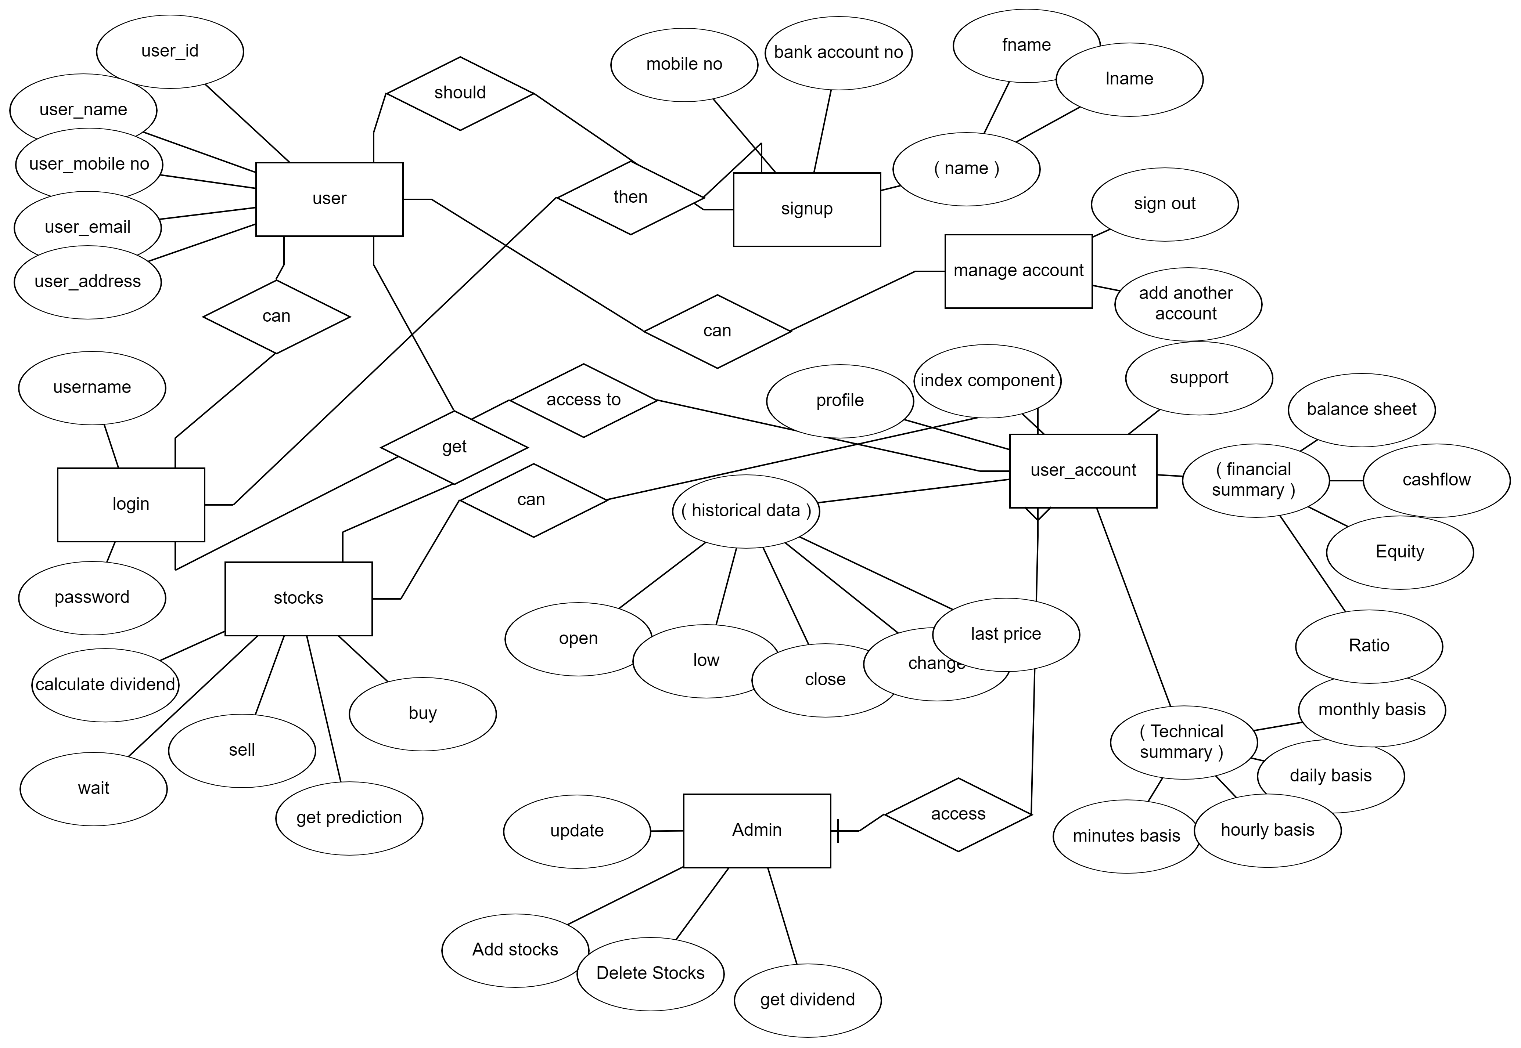

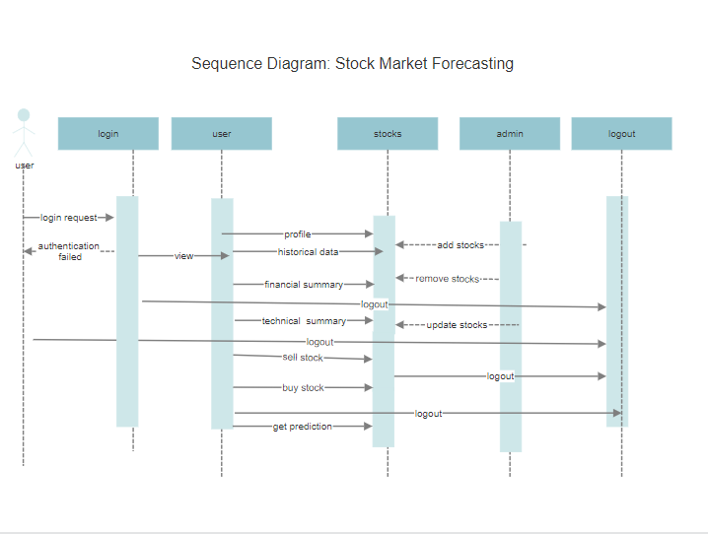

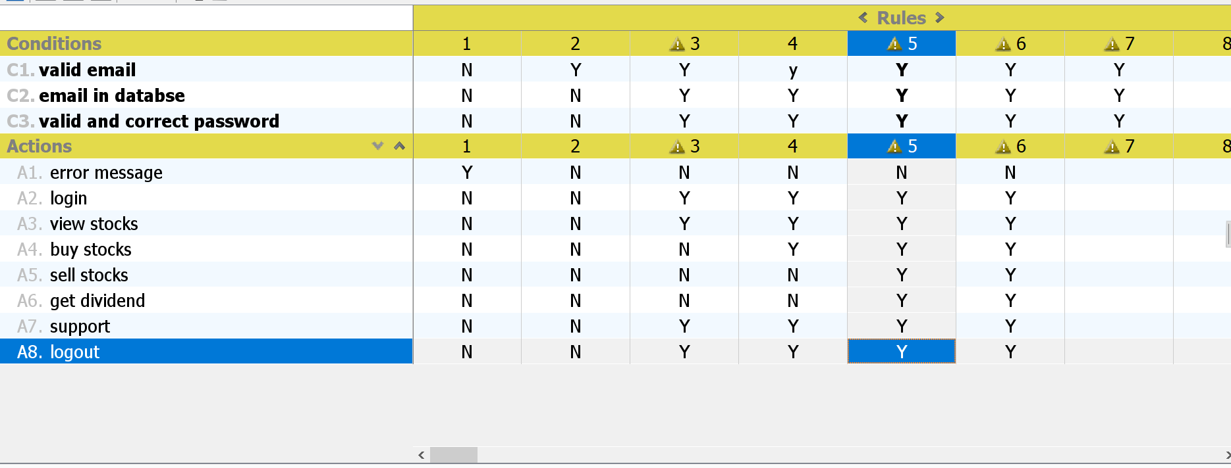

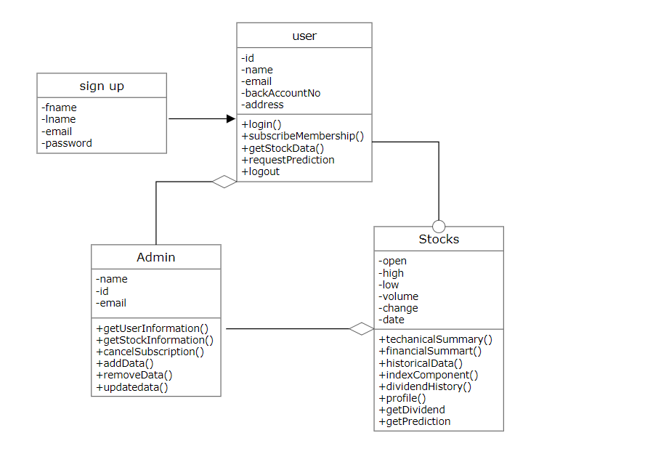

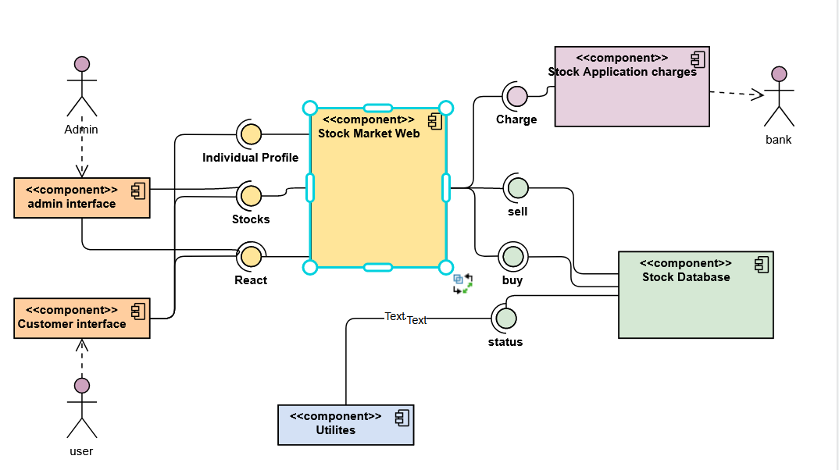

Component Interactions and Collaborations

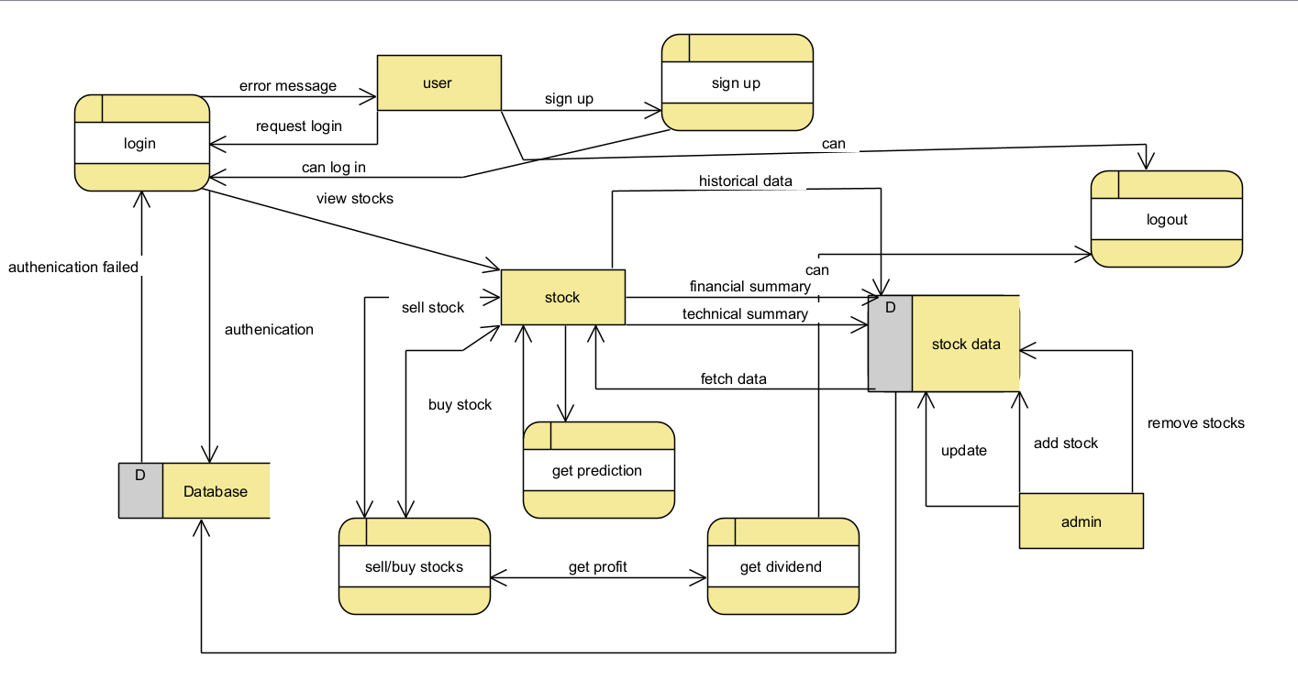

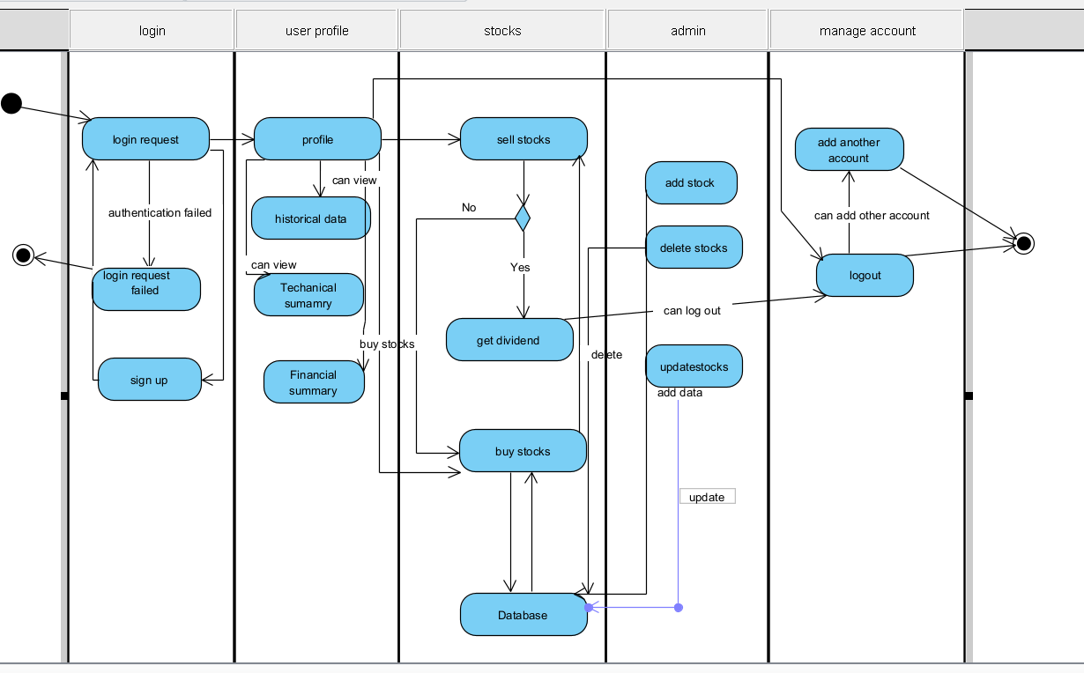

Design Reuse and Design Patterns
We haven't employed any design patterns in particular.

Technology Architecture
The presentation layer of the system is based on the react (JavaScript) framework. Nodejs, express js, and python are used to develop the logic. As a data layer, data is saved in a MongoDB database. AWS or A2hosting will host the system. The user will use the GUI (presentation layer) to request data, and the server will scrape the data, store it in the data layer, and deliver it back to the user. To request/use the data in any manner, the user must first log in.

Architecture Evaluation
We didn't leverage any existing APIs and instead created our own by scraping data from other websites. Our server will scrap data from other websites, store it in our database, and then deliver it back to the client.

Detailed/Component Design

Component-Component Interface

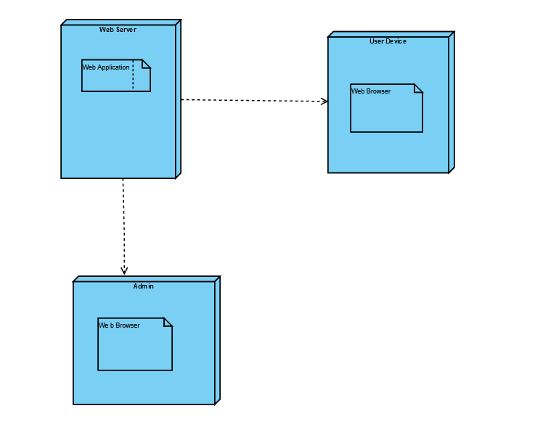

Component-External Entities Interface

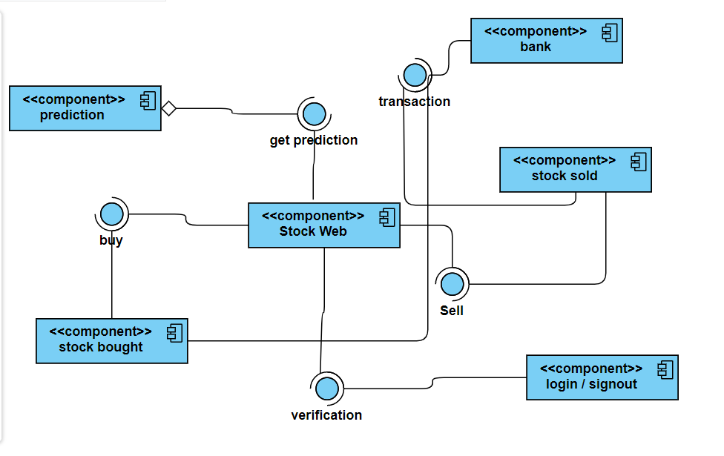

Component-Human Interface

As an input, a user looked for a specific bank stock, and as an output, it obtained historical data.

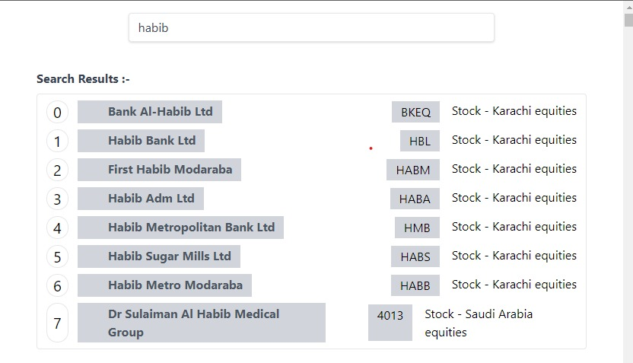

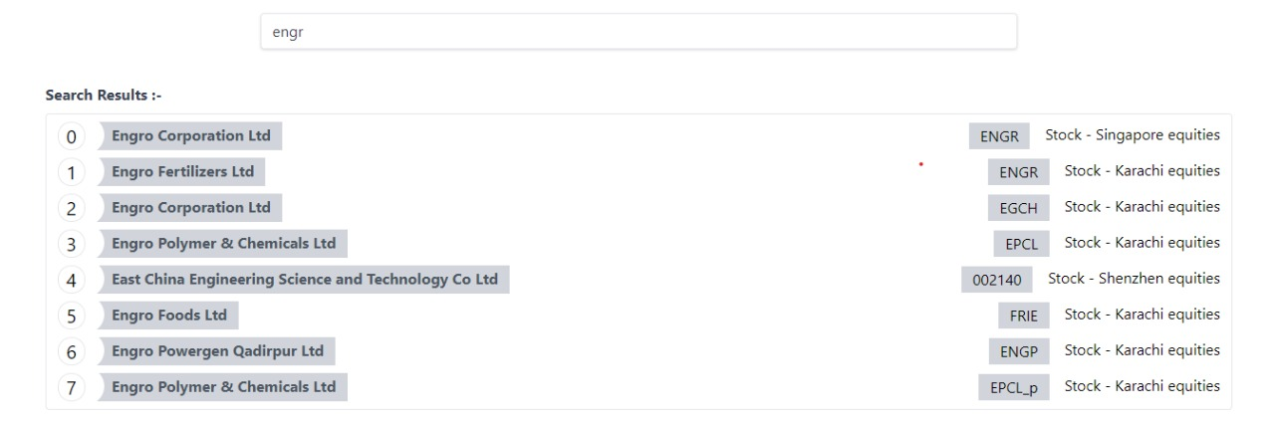

Screenshots/Prototype

Workflow

Screens
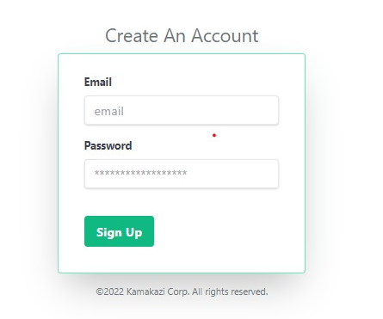

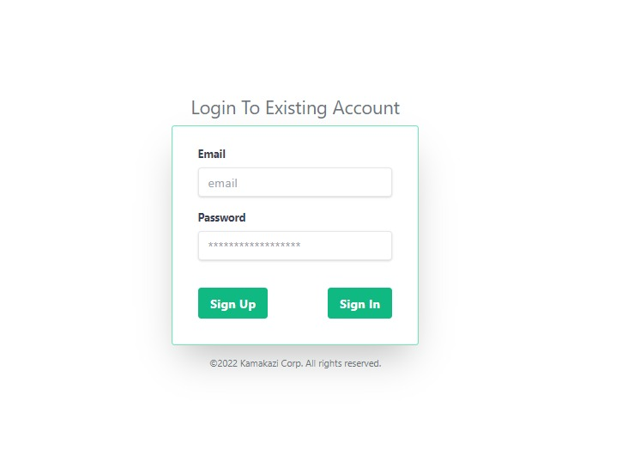

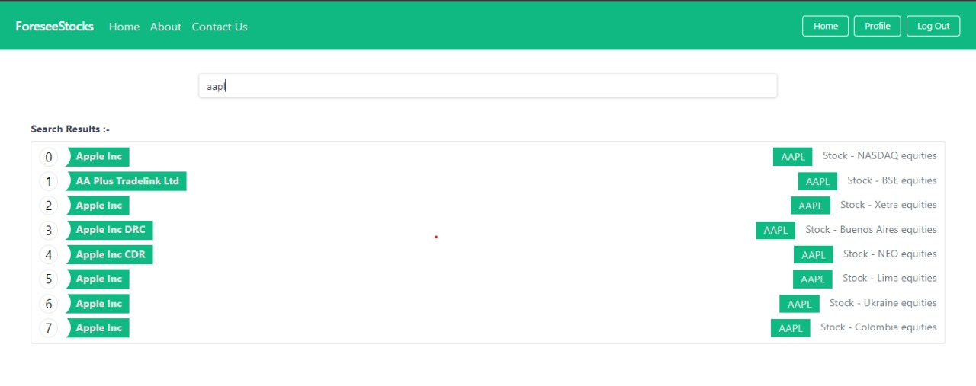

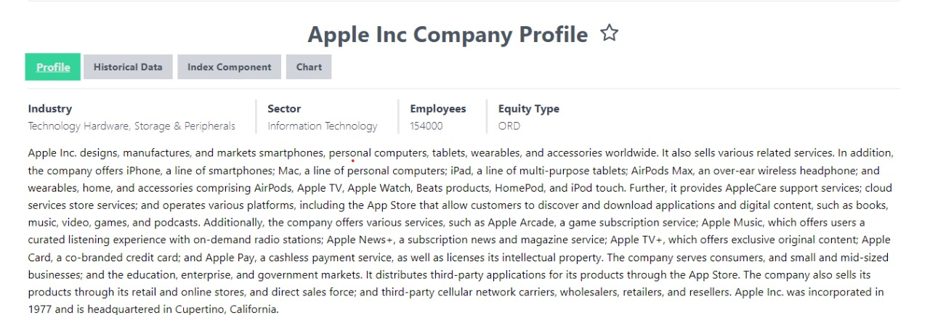

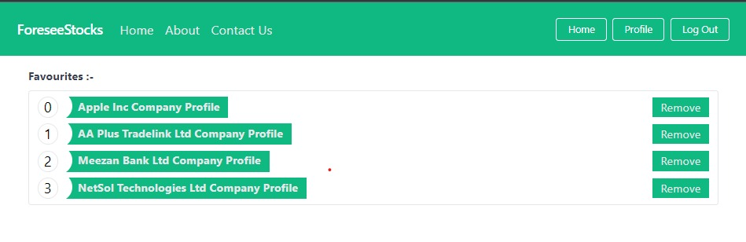

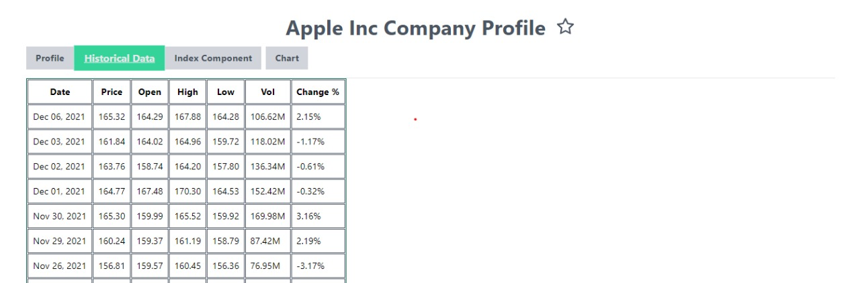

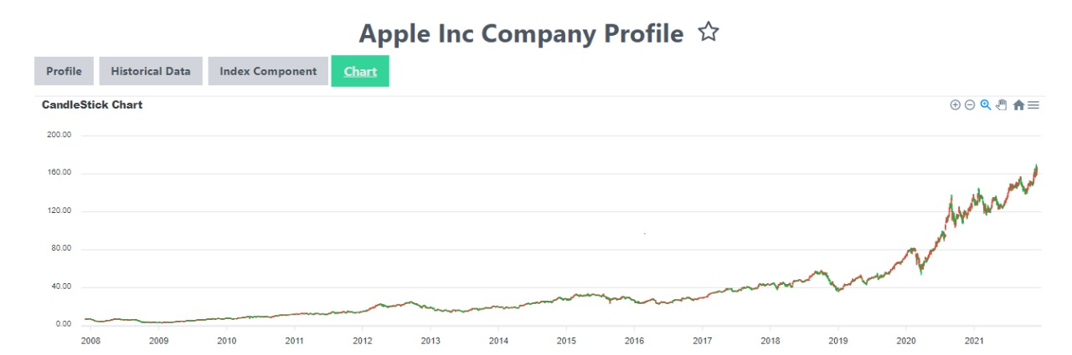

Additional Information
Our webapp is the first in Pakistan to incorporate features such as tagging a stock as a favourite, downloading stock data in csv format, watching a candlestick chart, and, of course, stock price prediction.

Other Design Details

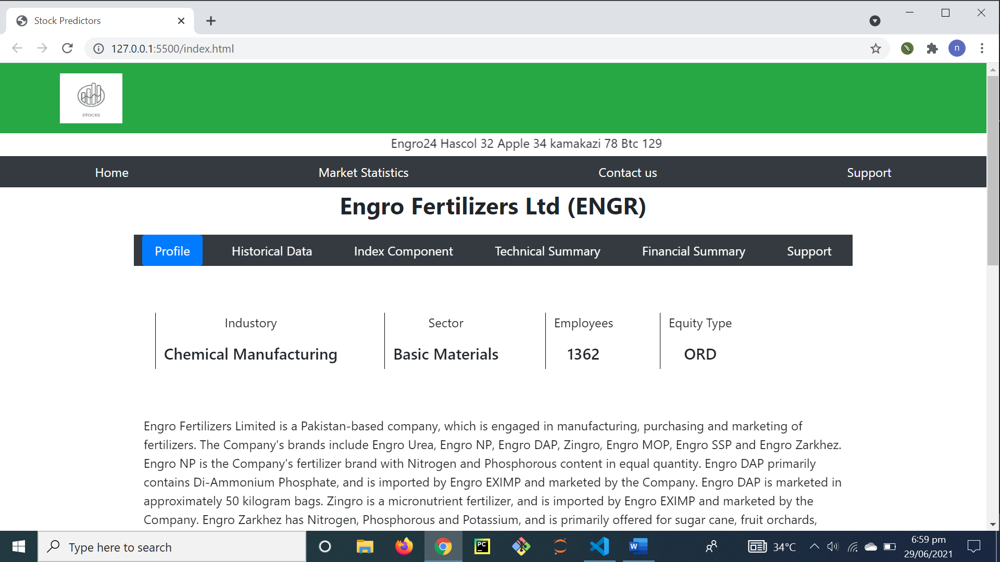

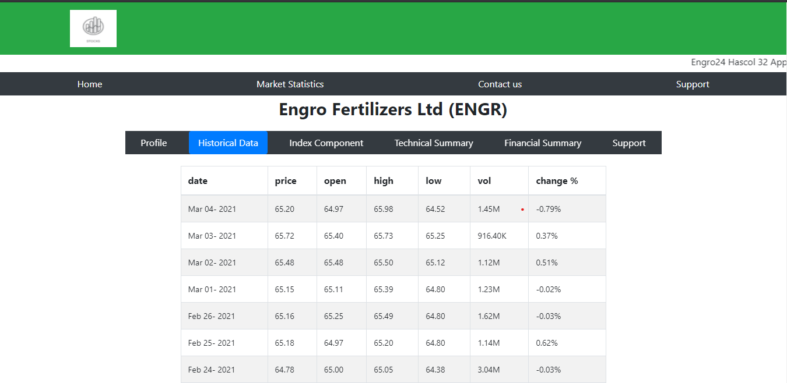

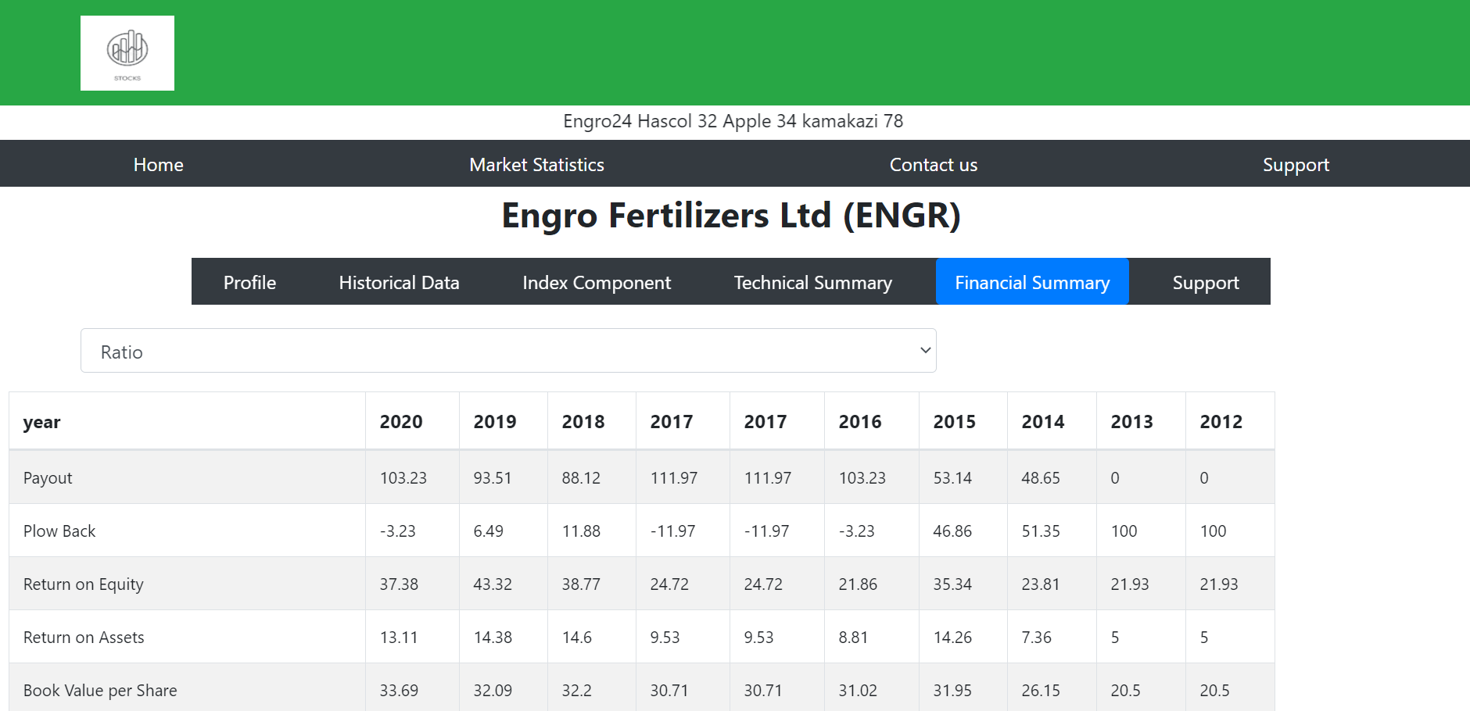

Test Specification and Results

Test Case Specification

Identifier | TC-1
Related requirements(s) | Login case
Short description | A user can only login with the right credentials
Pre-condition(s) | Email box
Input data | naumangmail.com
Detailed steps | User has to move cursor to email box
Expected result(s) | Show error as there is no @ in email
Post-condition(s) | Password box
Actual result(s) | Password required
Test Case Result | Fail

Identifier | TC-2
Related requirements(s) | Login case
Short description | A user can only login with the right credentials
Pre-condition(s) | Email box
Input data | nauman@gmail.com
Detailed steps | User has to move cursor to email box
Expected result(s) | Should ask for password
Post-condition(s) | Password box
Actual result(s) | Password required
Test Case Result | Pass

Identifier | TC-3
Related requirements(s) | Password
Short description | A user cannot login if the password is incorrect
Pre-condition(s) | Password box
Input data | 123456
Detailed steps | A user has to move cursor to password box
Expected result(s) | Should show error as the password is incorrect
Post-condition(s) | Should ask for to re enter the password
Actual result(s) | Error
Test Case Result | Pass

Identifier | TC-4
Related requirements(s) | Password
Short description | A user can login if the password is correct
Pre-condition(s) | Password box
Input data | 123@456
Detailed steps | A user has to move cursor to password box
Expected result(s) | Should login
Post-condition(s) | User profile
Actual result(s) | Logged in
Test Case Result | Pass

Identifier | TC-5
Related requirements(s) | Favorite
Short description | A user can favorite a stock
Pre-condition(s) | Stock search
Input data | Favorite option selection
Detailed steps | A user has to move cursor to favorite option
Expected result(s) | Should mark as favorite
Post-condition(s) | Show on user profile
Actual result(s) | Shows favorite stock on user profile
Test Case Result | Pass

Identifier | TC-6
Related requirements(s) | Historical data request
Short description | A user will and can request for historical data
Pre-condition(s) | User profile
Input data | Request for historical data
Detailed steps | A user has to request for historical data to see the trend of the stock
Expected result(s) | Requested Historical stock data should be displayed
Post-condition(s) | Historical data shown.
Actual result(s) | Stock data in different format will be shown , user is able to download a .csv/.xlsx format of file.
Test Case Result | Pass

Identifier | TC-7
Related requirements(s) | Request prediction
Short description | A user can always request a stock prediction of his own choice.
Pre-condition(s) | Historical data
Input data | Request for forecasting
Detailed steps | A user will have to select the option of forecasting to make a prediction
Expected result(s) | User should get prediction
Post-condition(s) | User will get prediction
Actual result(s) | User will receive the specific stock prediction
Test Case Result | Pass

Identifier | TC-8
Related requirements(s) | logout
Short description | A user can always logout whenever he wants.
Pre-condition(s) | Prediction page
Input data | Click on logout
Detailed steps | A user will have to move the cursor to logout option.
Expected result(s) | A user should logout from his account.
Post-condition(s) | Login /sign up page
Actual result(s) | A user will logout from his account
Test Case Result | Pass

Summary of Test Results

Table 6.2: Summary of All Test Results
Module Name | Test cases run | Number of defects found | Number of defects corrected so far | Number of defects still need to be corrected
login | TC1 | 2 | 2 | 0
password | TC2 | 3 | 3 | 0
Data Request | TC3 | 0 | 0 | 0
Request Prediction | TC4 | 2 | 1 | 1
Mark Favorite | TC5 | 2 | 2 | 0
logout | TC6 | 1 | 1 | 0
Complete System | 6 | 10 | 9 | 1

Project Completion Status
Table 7.1: Project Completion Status
Module Name | Status  (Complete, Partially Implemented, Not Implemented)
Web scrapping | Complete
API building | Complete
Web development | Complete
Algorithm | Complete
Web integration algorithm | Partially implemented
Complete System | Partially Implemented

Table 7.2: Objective(s)/Target(s) Status
Target/Objective | Status  (Completed,  Partially Completed,  Not Completed) | Reason(s)
Scrapping | complete
Charts | complete
Historical data | complete
Get dividend | Not completed
Get prediction | Partially completed
Favorite stock | complete | Additional work
Number of Targets Completed | 4
Number of Targets Partially Completed | 1
Number of Targets Not Completed | 1

Deployment/Installation Guide

Following is the installation guide of our project

Download Anaconda
Launch jupyter notebook
Install following libraries

!pip install pandas
!pip install numpy
!pip install matplotlib
!pip install seaborn
!pip install pmdarima
!pip install ARIMA
!pip install sklearn
Run code

User Manual

Step 1: Click on create an account

Step 2: Enter email and password for making an account

Step3: Enter the existing credentials for logging in

Step 4: Signed into new account (Welcome to ForseeStocks)
Step5: Click on search bar to search for any stocks

Step5: Click on Favorite sign to mark any stock favorite , or to buy/sell stock in future

Step7: Click on Home button to view /remove favorite stocks

Step8: Click on Historical data or charts to view/download trends of a stock

Step9: Click on log out if user wants to log out.

References

https://www.tradingview.com/
https://abbasiandcompany.com/

https://ieeexplore.ieee.org/abstract/document/7373006
https://ieeexplore.ieee.org/abstract/document/6199099
https://link.springer.com/chapter/10.1007/978-3-030-11890-7_52
https://ieeexplore.ieee.org/abstract/document/5643675

https://www.scientific.net/AEF.6-7.1055
https://www.sciencedirect.com/science/article/pii/S1877050920304865
https://arxiv.org/abs/1311.4771

https://www.statisticssolutions.com/time-series-analysis
https://link.springer.com/article/10.1007/s42979-020-00180-5
https://www.khistocks.com
http://scstrade.com/stockscreening/SS_CompanySnapShot.aspx?symbol=DGKC
https://www.psx.com.pk

https://finviz.com
https://www.earningswhispers.com/calendar
https://seekingalpha.com
https://www.investing.com/equities/meezan-bank
https://biplsec.com/Files/Equities/Account-Openning-Form-Equities-for-Individuals.pdf
https://tradingeconomics.com/pakistan/stock-market

http://scstrade.com/TechnicalAnalysis/TA_TechnicalReport.aspx
http://scstrade.com/MarketStatistics/MS_HeatMap.aspx
http://scstrade.com

https://www.ksestocks.com/BookClosures?__cf_chl_jschl_tk__=067ba6f49f81641afee7328130457ad60087ca88-1620059008-0-AYvZrrqVjTXhNg8aeR96B7fA0jEtflHfmfesVYKsa5wP0NliGRkpTzET2zgep_ZkKQnp4Cu2MJpJrbMpPIRjZzbwrp5Ni_MdfPAVgEj-IVf RlJ1Z0BINv1mgbdEZYMjhflmhKIz9XLY64LA3BiL-XgKyaaoE4K7P2eAnZwRdLsAagYtkaNcrm0kE30fdk-3L5bDHZTKDYEfmoYnRVLuk-G8QtZQaM4oanTln1fRcqi5OpAuvR3DOQMFCCsfqPA9UWv1FwaVmhhooBF1BgdHPeEt5fZH1B6GItGXQswwxSR34faTAHArsOCsmnh8OgFaJWCFxZHyEDJC8jeMaO_N7UzUAHv9YnNEFzUrg_eBKCUa0Nv4aRdfj4ONFaG-03MjOTK4BUsaFf-SKtxZGC3YFd-L_OBL-pAWJu27jC-4XyTmb

https://ieeexplore.ieee.org/abstract/document/7522190
https://ieeexplore.ieee.org/abstract/document/7522190
https://ieeexplore.ieee.org/document/7321293
https://ieeexplore.ieee.org/document/9009178

https://ieeexplore.ieee.org/abstract/document/7522190
https://www.kdnuggets.com/2020/01/stock-market-forecasting-time-series-analysis.html
https://jfin-swufe.springeropen.com/articles/10.1186/s40854-019-0157-x
https://tradingeconomics.com/forecast/stock-market
https://www.investopedia.com/articles/07/mean_reversion_martingale.asp

https://online.visual-paradigm.com/w/anyaayja/drive/#infoart:proj=0&dashboard
https://www.kdnuggets.com/2020/01/stock-market-forecasting-time-series-analysis.html
https://ieeexplore.ieee.org/document/7321293
https://ieeexplore.ieee.org/document/9009178

http://scstrade.com/MarketStatistics/MS_HeatMap.aspx
http://scstrade.com
https://erdplus.com/

Appendix A: Glossary
Tools:
- PyCharm
- Vs Code
- Jupyter Notebook
- Google colab
- Appendix B: IV & V Report
(Independent verification & validation)
IV & V Resource

Name Signature

S# | Defect Description | Origin Stage | Status | Fix Time
 |  |  |  | Hours | Minutes
1
2
3
…
Table B.1: List of non-trivial defects

This document has been adapted from the following:
- Previous project templates at UCP
- High-level Technical Design, Centers for Medicare & Medicaid Services. (www.cms.gov)

